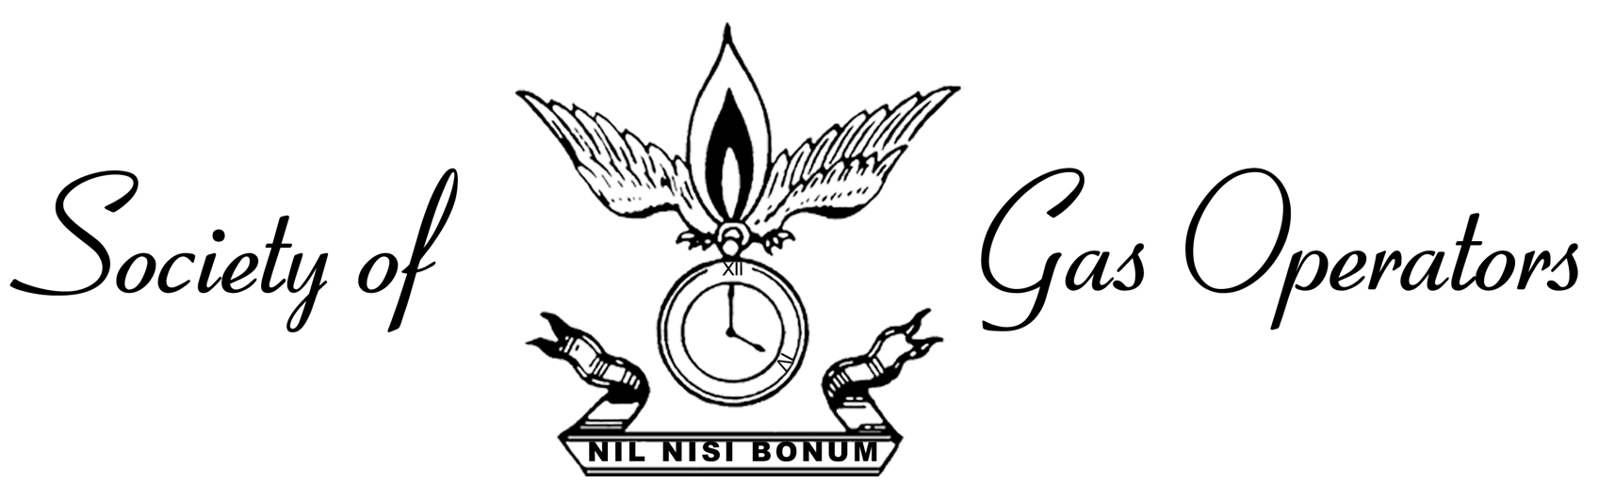

CALL FOR NOMINATIONS

DICK MORGAN HEROISM AWARD PROGRAM

Purpose

To provide recognition for extraordinary service or acts of heroism performed by an employee of a member company.

Selection Process

Any SOGO member may nominate a candidate(s). The SOGO Executive Committee will act as the selection committee for the Award. If the Executive Committee receives no nominations or finds nominations not fulfilling the spirit of the Award, no Award may be given that year.

The Award Process

The honoree(s) shall be notified in writing by the “Society” of the Award, along with the honoree(s)’ Company and SOGO members of that Company.

The award will consist of a plaque and a $500 check per honoree, and the honoree(s)’ name(s) will be entered on a SOGO honor roll that shall be kept and maintained by the Society.

Details

The award is planned for the May 2025 Regular Meeting. Nominations must be submitted in writing to the Secretary, Anthony Mancino to mancinoa@coned.com by April 1, 2025. Nominees must be employees of a member company and be engaged in natural gas operations as part of their normal duties. The service or act(s) of heroism must be within the time period of October 1, 2023, to March 31, 2025. The nomination must include a description of the service or act of heroism, when it occurred, the nominees’ name, title, and any other pertinent supporting data.

The last 8-year award winners were:

2016 – Michael O’Neill and Harris Cosme (Con Edison)
2017 - Essa Waggeh (Con Edison)
2018 – Willaim Freiwald & Michael Getkin (UGI Utilities, Inc.)
2019 - Kyle Christman (UGI Utilities, Inc. ) and Chris Delgado (Con Edison)
2020 - James Lynch, Ross Dailey & Ted Ryder (Orange & Rockland Utilities)
2021 – No award
2022 – Ramy Shalabi, (Con Edison)
2023 – John Vellucci & Jeremy Farney (Con Edison)
2024 – Michael Conway (National Fuel Gas)

DICK MORGAN HEROISM AWARD NOMINATION

NOMINEE:

TITLE:

COMPANY:

DATE OF ACT:

BRIEF DESCRIPTION OF WHY NOMINEE SHOULD RECEIVE AWARD:

SUBMITTED BY: COMPANY:

PLEASE RETURN TO ANTHONY MANCINO mancinoa@coned.com BY APRIL 1, 2025

